**Pressure Controller**

**Documentation**

***Content:***

* Introduction
* Methodology
* Requirement Diagram
* Space Exploration
* System Analysis: Use Case Diagram
* System Analysis: Activity Diagram
* System Analysis: Sequence Diagram
* System Design
* Verification and Validation
* Analysis
* Simulation

***1 – Introduction:***

A Pressure Controller informs the crew of airplane when the pressure is greater than 20 bar, and the crew gets the information by Alarm for 60 Sec.

**Assumptions:**

- The system setup and shutdown procedures are not modeled.

- The system maintenance is not modeled.

- The pressure sensor never fails.

- The alarm actuator never fails.

- The system never faces power cut.

***2 – Methodology:***

- The System has multiple modules we need to integrated so we will choose a based model such as (V-Model) to help us in this integration

***3 - Requirement Diagram:***

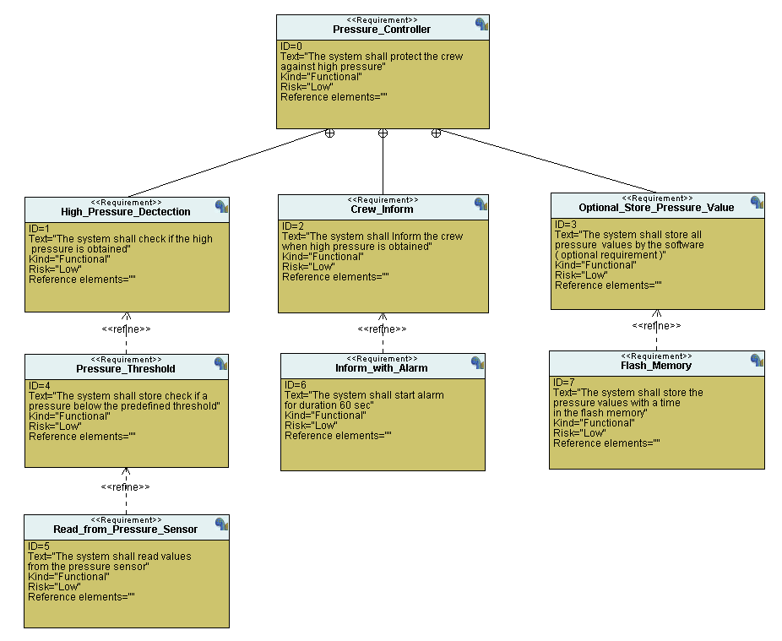

***4 - Space Exploration:***

For a Hardware we will use STM32 Board with a Processor Cortex-M3 and this board enough to run this application

***5 – System Analysis: Use Case Diagram***

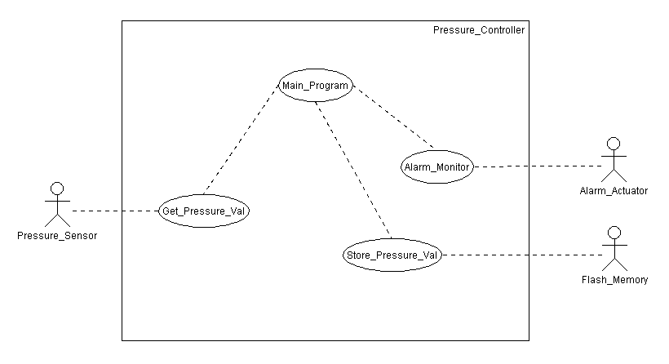

***6 – System Analysis:*** ***Activity Diagram***

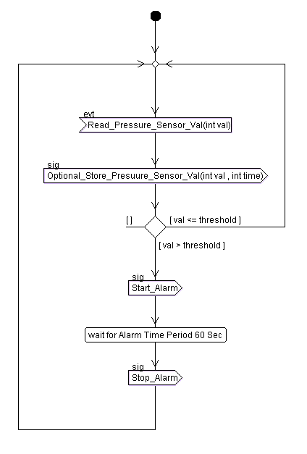

***7 – System Analysis:*** ***Sequence Diagram:***

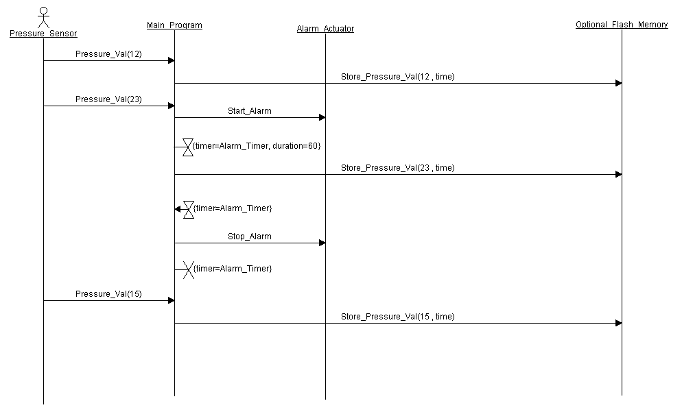

***8 – System Design:***

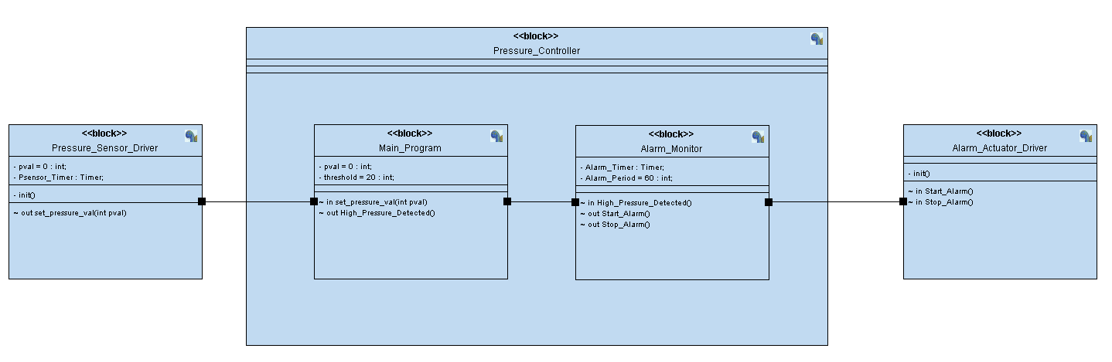

***Pressure_Sensor_Driver Module:***

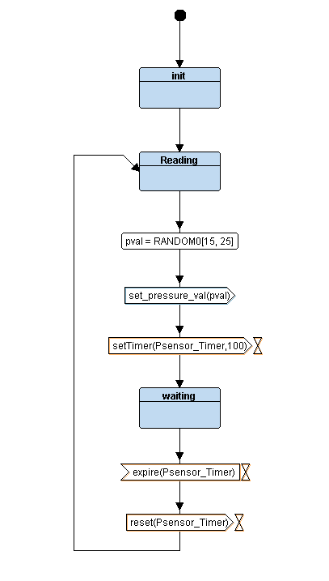

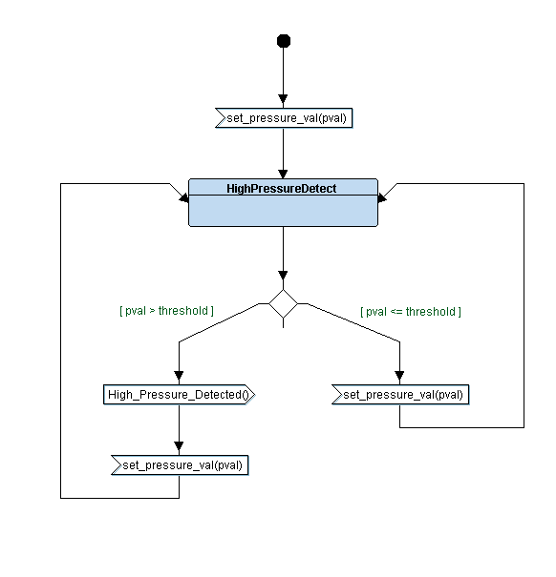***Main_Program Module:***

***Alarm_Monitor Module:***

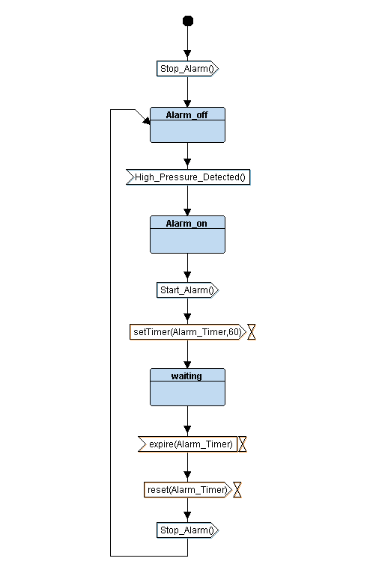

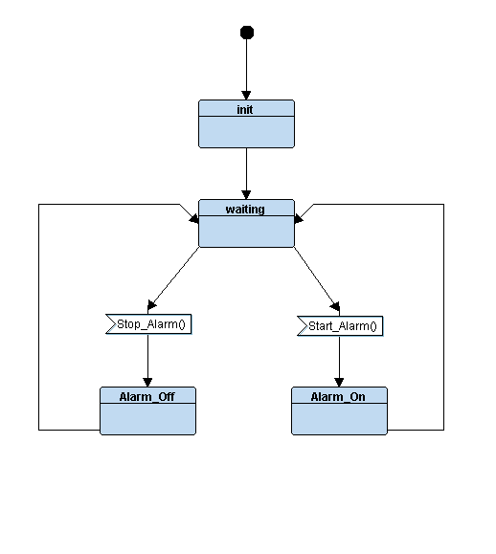***Alarm_Actuator_Driver Module:***

***9 - Verification and Validation:***

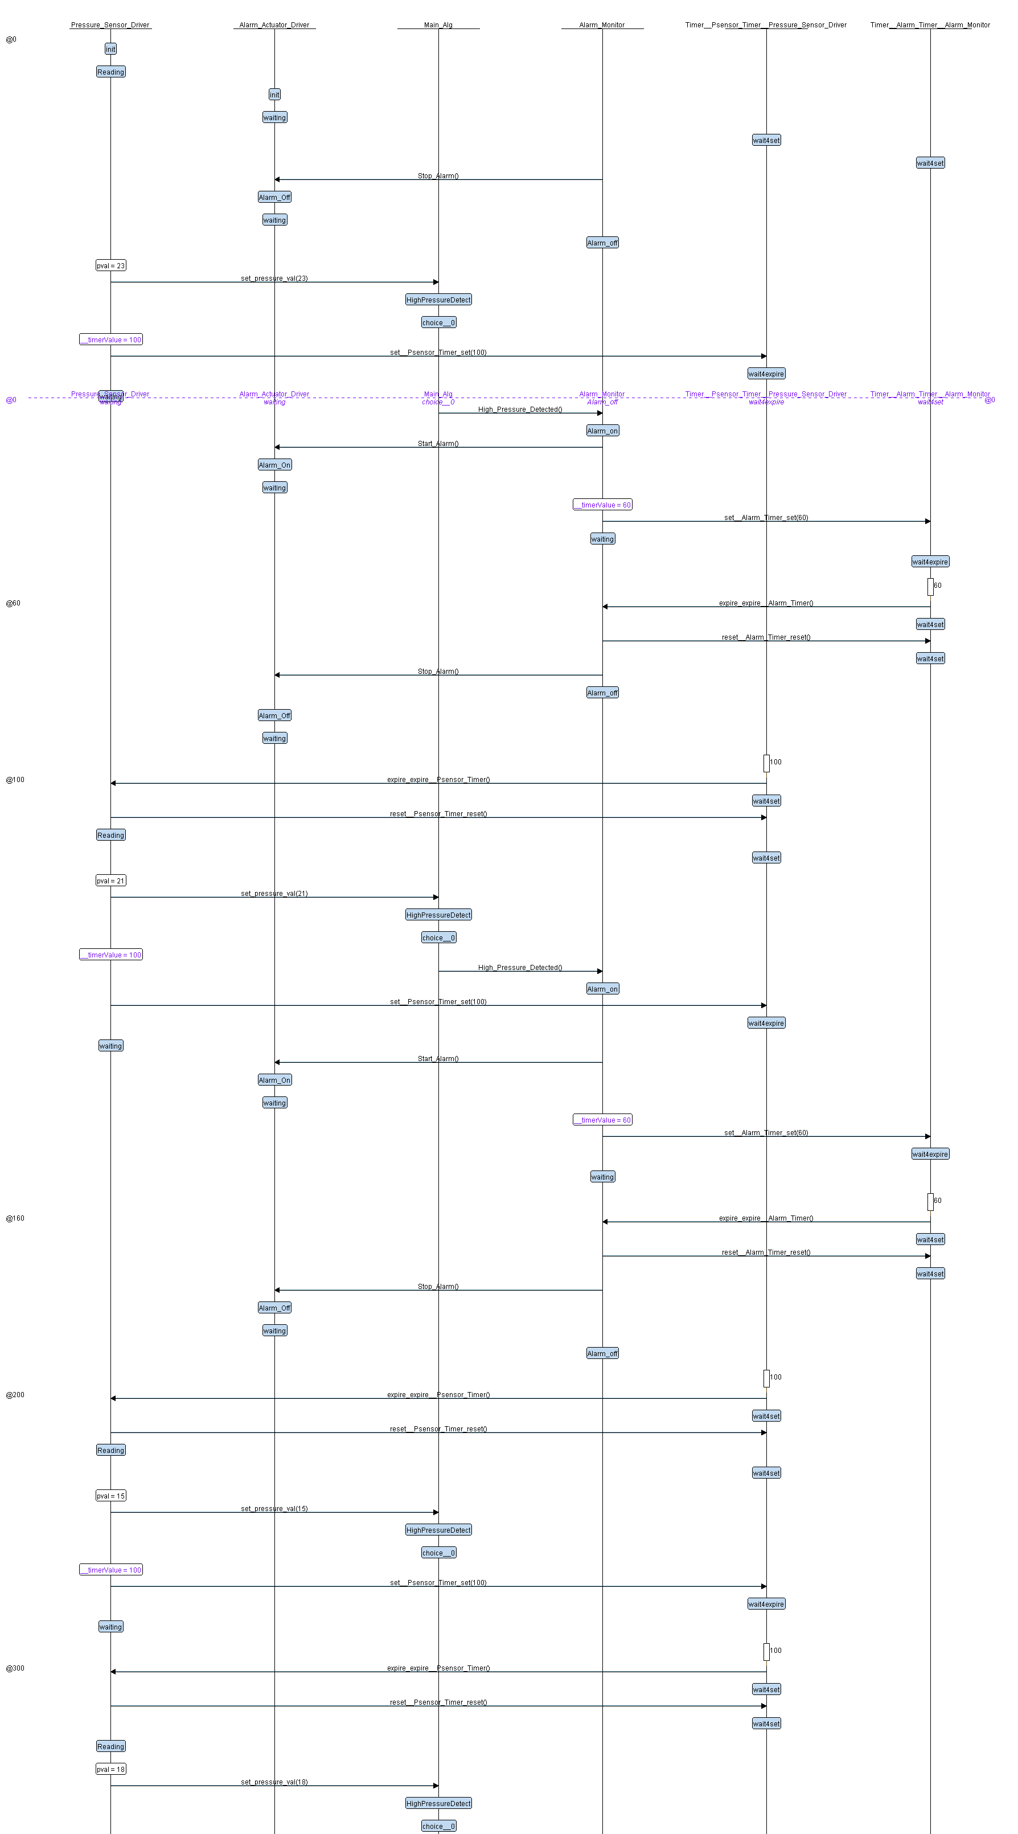

***11 – Analysis: Symbol Table:***

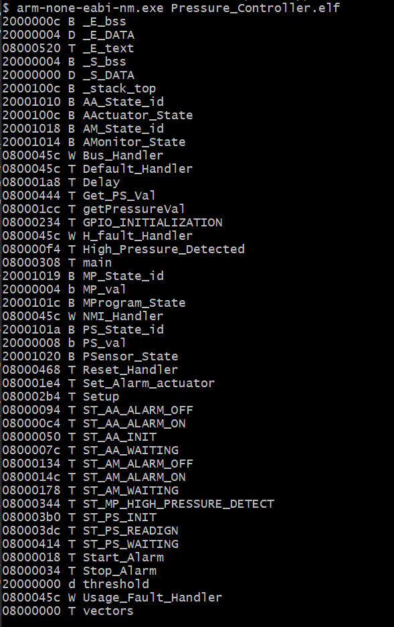

***Map File:***

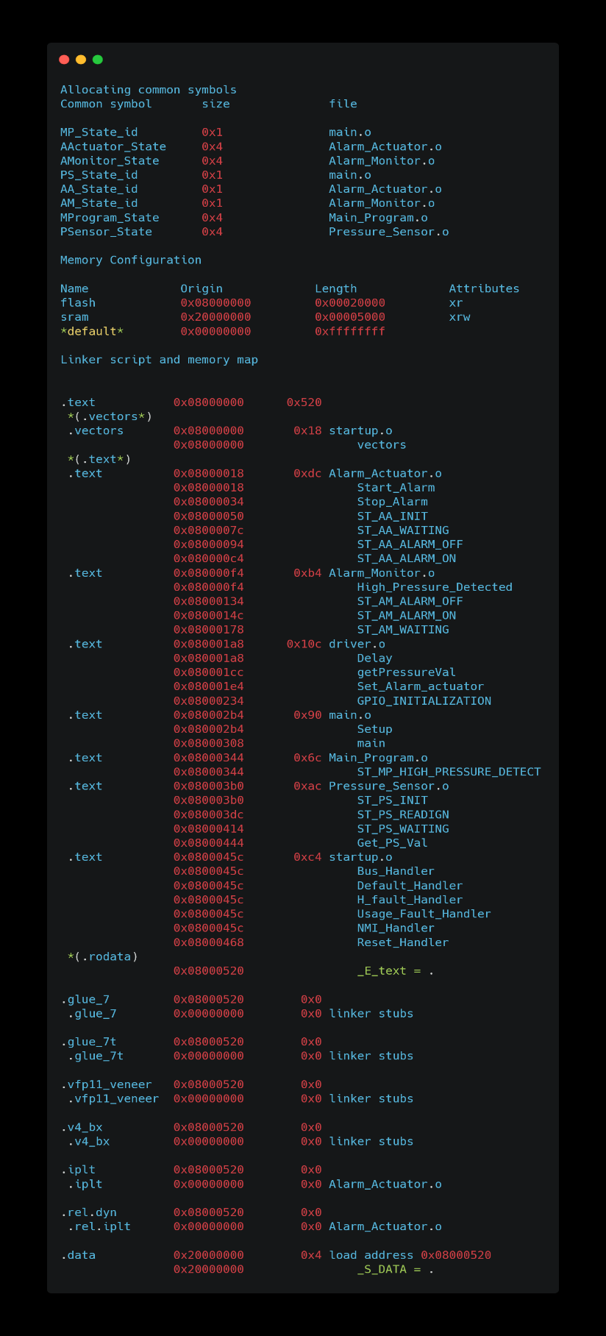

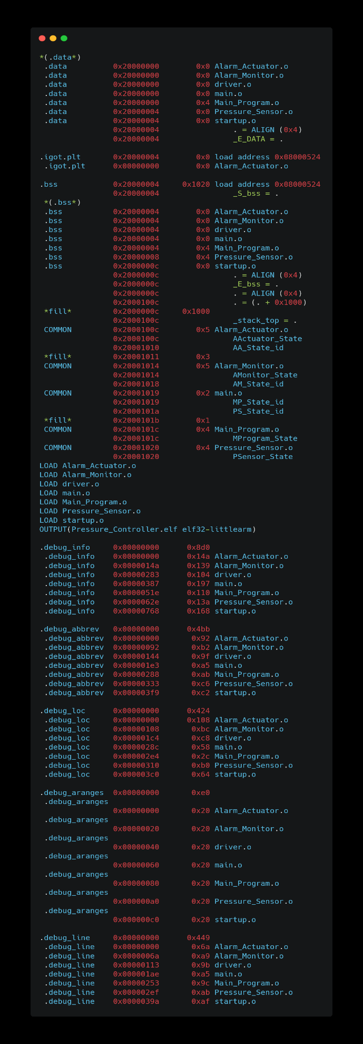

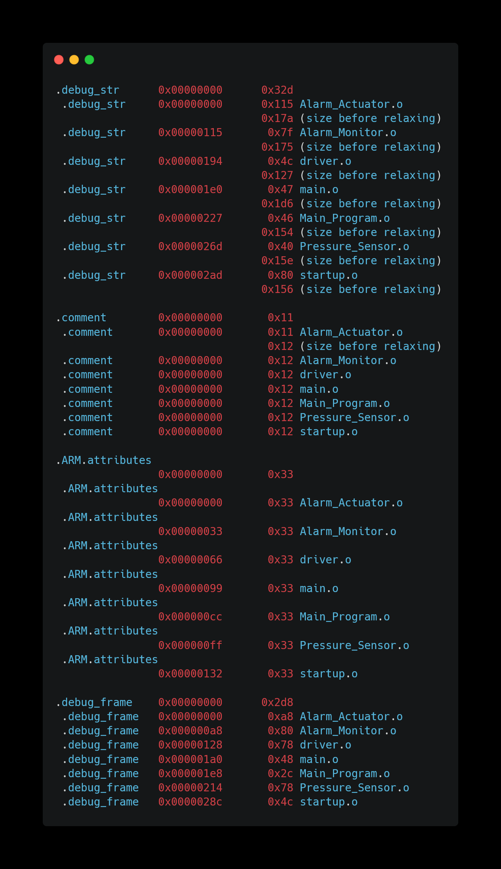

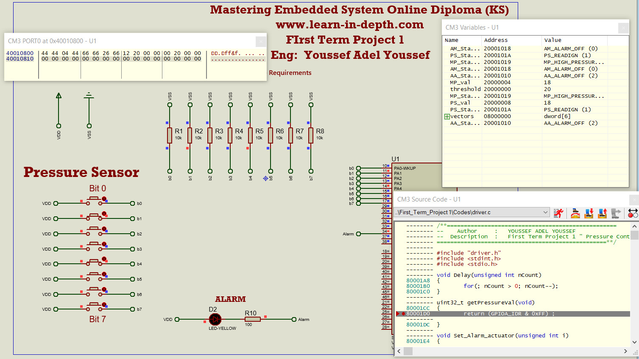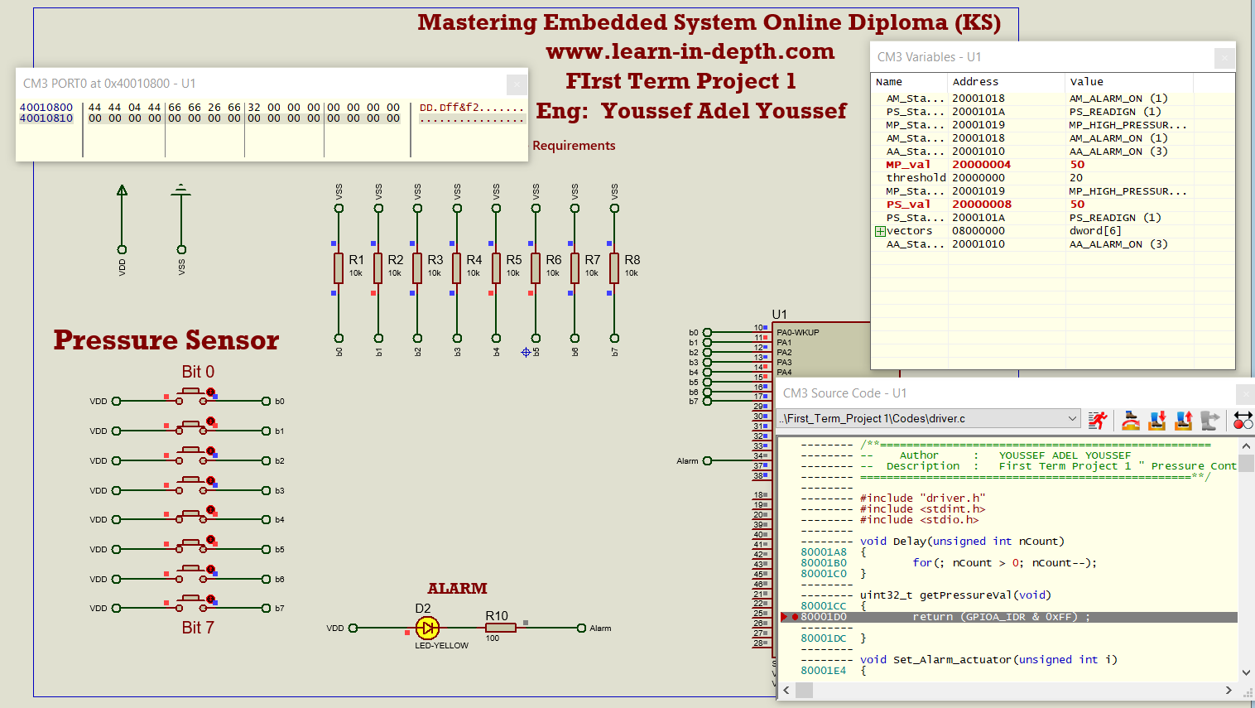***12 - Simulation:***